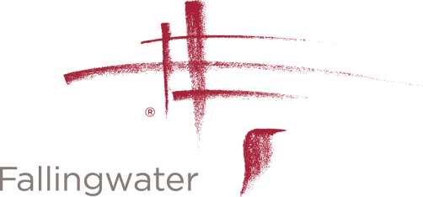
PROFESSIONAL PHOTOGRAPHY PERMISSION FORM

Fallingwater and the Western Pennsylvania Conservancy will not sign general releases giving blanket permission for stock agencies to use photos taken at Fallingwater.

By signing below, I agree that any photographs or video/film footage I take at Fallingwater will not be used for advertising or commercial products or services.

Photographer / Videographer Information

Name
Address
Phone Number

Email Address
Date of Visit
Purpose of Visit

Please return form to Clinton Piper, Museum Programs Assistant.

Clinton Piper

cpiper@paconserve.org

Fallingwater
PO Box R
Mill Run, PA 15464

(724) 329-8501

