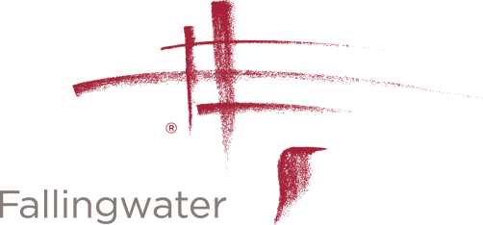VOLUNTEER APPLICATION

Contact Information

Name
Address
City, State, ZIP

Daytime Phone
E-mail Address
Are you 18 years of age or older? | Yes No  If under the age of 18, please provide your date of birth: ______________ (mm / dd / yyyy)

What is the best method for contacting you?
- Phone (Please enter alternate number if different from above): ___________________
- E-mail
- Other (please specify): ____________________________________________________

Availability
During which hours are you available for volunteer assignments?
- Weekday mornings | - Weekend Mornings
- Weekday afternoons | - Weekend Afternoons
- Weekday evenings | - Weekend evenings

Interests
For what program areas are you interested in volunteering?
- Interpretive Guides | - Visitor Services
- Exhibition Gallery | - Retail
- Grounds / Gardening | - Café / Food Service
- Family Activities | - Membership
- Special Events | - Architecture / Drafting
- Clerical | - Photography

Special Skills or Qualifications
Summarize special skills and qualifications you have acquired from employment, previous volunteer work, or other activities.

Previous Volunteer and Employment Experience
Summarize your previous volunteer and employment experience.

Why Do You Want To Volunteer at Fallingwater?
Summarize your reasons for wishing to volunteer at Fallingwater.

Our Policy
It is the policy of this organization to provide equal opportunities without regard to race, color, religion, national origin, gender, sexual preference, age, or disability.

Volunteers are not entitled to monetary compensation for the work performed or entitled to group benefits. A Fallingwater supervisor, together with individual volunteers, will evaluate volunteer performance. If at anytime it is determined that responsibilities are not being satisfactorily fulfilled, either party has the right to terminate the relationship.

Thank you for completing this application form and for your interest in volunteering with us.
Updated July 7,2017

