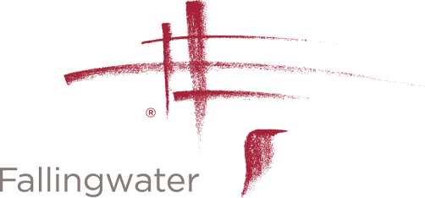

PROFESSIONAL PHOTOGRAPHY & FILMING PERMISSION FORM

Fallingwater and the Western Pennsylvania Conservancy will not sign general releases giving blanket permission for stock agencies to use photos taken at Fallingwater.

By signing below, I agree that any photographs or video/film footage I take at Fallingwater will not be used for advertising or commercial products or services. In addition, any website or social media use must be cleared and approved through the Western Pennsylvania Conservancy. No drone footage is permitted.

Photographer/Videographer Information

Name
Address
Phone Number

Email Address
Date of Visit
Purpose of Visit

Signed: _______________________________________________________

Please return form to Clinton Piper, Senior Administrator of Special Projects

Clinton Piper

cpiper@paconserve.org

Fallingwater
PO Box R
Mill Run, PA 15464

(724) 329-7821

